Correctiesleutel Leertakenschrift blok 7

G8, p 11

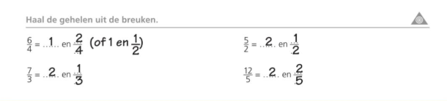

G13, p 16

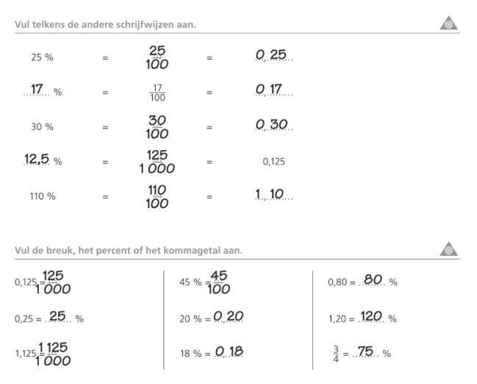

G12, p 14



G12, p 15

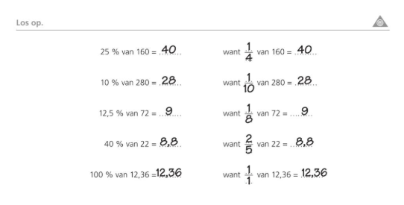

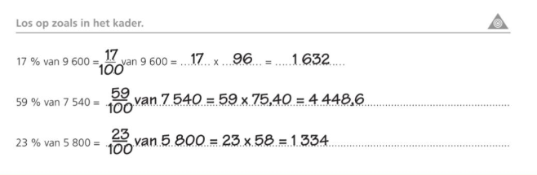

B13, p 39

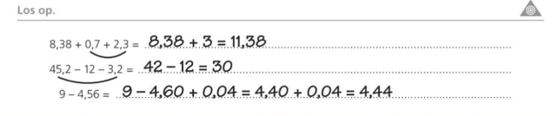  
MMR10,p 66

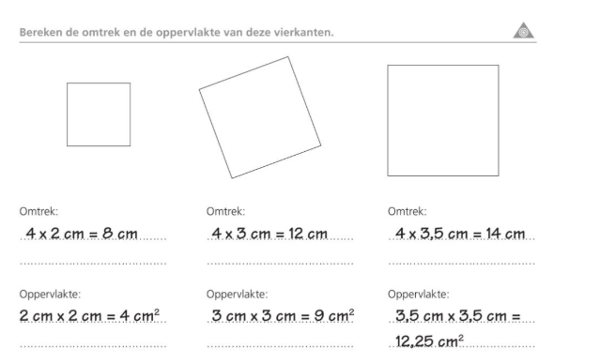

MMR11,p 67

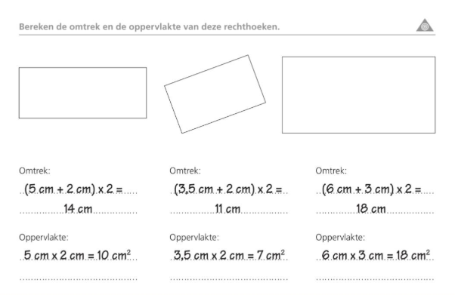

MMR 12, p 68

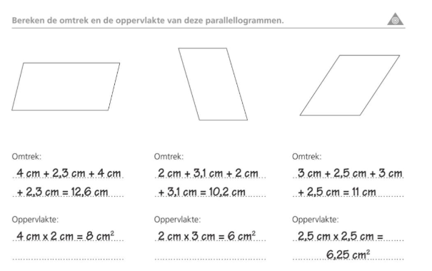

MMR 14, p 70

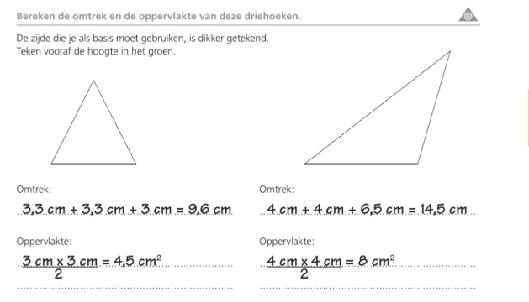

MMR 20, p 74

